Short paper: <10 pages- Draft
Forensics for the body farm: Preferences for the medicinal blow fly (Phaenicia sericata) and fruit fly (Drosophila melanogaster)
Oscar Istas¹, Abigail Greenhalgh¹, Erin E. Richard¹, Jate Bernard¹, Rebecca Krall², Tawny Aguayo², and Robin L. Cooper¹
¹Dept. of Biology, Univ. of KY., Lexington, KY.
²Dept. of STEM, Univ. of KY., Lexington, KY.
(owis222@g.uky.edu; Abigail.Greenhalgh@uky.edu; erin.richard@uky.edu; atebernard@gmail.com; rebecca.krall@uky.edu; taguayowilliams@gmail.com; RLCOOP1@uky.edu)

Learning about bacteria, fungi, or the developmental stages of insects does not always have the “wow” factor for many college students. If you add a dead body to the mix, it’s amazing how their interest is piqued. An interactive forensic science module was developed with this storyline to provide an authentic forensic investigation of a dead animal. Forensic science considers many variables when documenting and determining conditions to identify the potential time frame of death. In particular, the presence, amount, and developmental stages of bacteria, fungi and insects are commonly used to aid investigations. The developmental stages and preference in behaviors of insects, and the decay of associated plant matter has proven to be particularly beneficial in determining the potential time frame of death of an animal. The case in this module presents a human that has died after taking a bite of fruit. Fruit flies and blow flies are found at the scene. Through experimentation, data gathering, and analysis of the life cycles and behavior of two animal models (fruit fly and blow fly), interpretations of the location of the insects and developmental stages of larvae and pupa lead to a logical assessment of the time of death. We simulated the experimental design of data collection at the scene using laminated copies of fruit fly and blow fly larvae in different developmental stages. The data set and specific details surrounding data collection are provided to support participants in determining the time frame of the dead animal using an experimental protocol. Protocols also are provided to guide the re-creation of the scene using physical models. The lab has been designed to be conducted in the laboratory or remotely using downloadable materials. The laboratory can also be adapted as a CURE class project.
Firstpage
Keywords: field work, classroom, insects, crime science investigations, inquiry-based learning

Introduction

The ability to solve problems given various content is rewarding for students (National Research Council, 2012). Curiosity can be piqued by the successful applications of data collection and analysis to an engaging topic, especially if multiple correct conclusions can be reached. In considering the strong interest in crime science investigations (CSI) currently in society, having an educational model to feed this interest could engage students familiar with the general topic. Bringing in forensic science is a means to introduce scientific investigation and complexity of the field. The diverse array of factors which contribute to forensic investigation allow the development of thinking on the implications of the environment in solving a problem. This format allows instructors to diversify instruction in a classroom each time the content is taught.
In this module, we set up a template for CSI by introducing elements of entomology, microbiology, and environmental science in order to work through a relatively superficial problem. As one dives deeper into the content, the more complex the investigations can become. This module is structured in a way to encourage further investigation in different avenues depending on the goals of the participants and instructors.
The scenario is that a human body (which could be substituted with a different mammal: a fruit eating bat or primate) was found in an open field with a bite taken out of an apple next to the body. The environment is set as a mild weather day (dry, 21ºC), but can easily be varied. In this exercise we focus on two insect species. The first is a common fruit fly (Drosophila melanogaster), which is found in the apple (which has a broken peel). This is a factor to be studied as Drosophila melanogaster will not lay eggs on an intact apple. The other insect is a blow fly, commonly known as the green fly, which consumes and lays eggs on decaying flesh from dead animals such as roadkill (i.e., deer, squirrels). The eggs and pupa of these two types of flies are unique in morphology and develop at different rates depending on the temperature. The apple and body can be identified with or without bacteria and fungi present to add a variable to examine the impact on the development and survival of the insects. The main focus is determining the time it would take to see empty pupal cases of the two fly species to estimate the time of death of the subject.
The investigation can be simulated with kits containing pictures of the flesh and apple with different developmental stages of the flies as well as with or without bacteria or fungi. The developmental stages of the insects are illustrated with a diagram of the stages and the time required to reach each of the stages. An instructor might put more empty pupa cases of one insect species as compared to the other to stimulate discussion about the behavior and egg-laying preference of the insects. Setting the temperature to a standard temperature of 21ºC in a dry environment would provide a quick determination of a window of time that the apple was bitten and dropped, considering Drosophila found the apple quickly and laid eggs. If an empty pupa case is found, then back estimation is about 8 to 9 days. However, the development is temperature dependent. This will allow participants to investigate how to obtain environment conditions from web-based sources of their own local environment or set dates and location an instructor chooses. The presence and types of bacteria and fungus can kill the embryos in the eggs as well as larva and pupa, which can alter the estimation in the time of occurrence of death .
In recreating the scene, laboratory investigations can be implemented with the insects on fruit and tissue such as beef liver or uncooked pieces of meat in either an indoor lab or an outdoor field setting. Indoors offers controlled conditions such as temperature, lighting, and humidity, whereas outdoors can be more variable and would require more investigation of environmental conditions during the time frame. To refine indoor investigations, plastic plates with tainted items (apple, meat) and inoculated bacteria or fungi can be implemented. This could be even more refined to include variation in toxins released by a given bacterial species such as lipopolysaccharides (LPS) by gram negative bacteria. Similarly, providing adult insects a choice in feeding and egg-laying material can encourage investigation into behavioral choices and impact with bacterial toxins on food.
We provide information including the development stages of both insect species which can be accessed by students online or cut out, placed in plastic bags, and mailed to students for hands-on remote learning. This content could also be emailed to students and encourage them to set up their own conditions for the investigation.
Student Outline
Objectives

Students will be able to:
1. Integrate observations to make predictions based on evidence.
2. Utilize literature research to help make a prediction.
3. Identify developmental stages and environmental impacts for the insects used in the study.
4. Create and design a model to support the evidence
5. Describe how forensic scientists use evidence and inference to solve a problem.
6. Discuss diet choices and impact of variables such as the presence of bacteria and their toxins for insect larvae.

Introduction

The premise of this module is a hypothetical crime scene where someone has died in a rural farm field. When the forensic team arrived, they noticed the man appeared to have taken a bite out of an apple sometime before his death, which was next to the body. They also noticed adult flies of the species Drosophila melanogaster and blow flies flying around the body and the apple. Photos were taken of the apple and the person where the flies were aggregating. The instructor of the module may provide varied data and details of the environment to present different scenarios to groups within a class or for different years in teaching this module. Below is the data we provide as a template for potential factors which could be relevant to determining the time of death of the body. Further investigation into the location and developmental stages of the insects will shed light on the matter.
The goal is for you to estimate the time frame in which the person died with or without additional experimentation. Protocols are provided to recreate the scene with physical modeling. Variations in the experimentation are detailed with agar plates and food for insect developmental studies. There are various tasks that one might be assigned to work through.

Conditions:
For the last 2 weeks, the weather has consisted of mild weather 70⁰F (21.1⁰C) during the day and at nighttime down to 55⁰F (12.8⁰C). The location is a horse farm in central Kentucky, USA in an open grassy field. No rain for the last two weeks was reported. Some gram-negative bacteria (Serratia marcescens) was present on the apple, along with a little bit of fungus.

The photo of the area is provided.

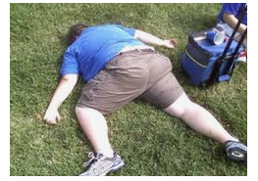
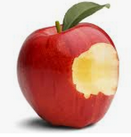

Figure 1: The body and apple in the location found

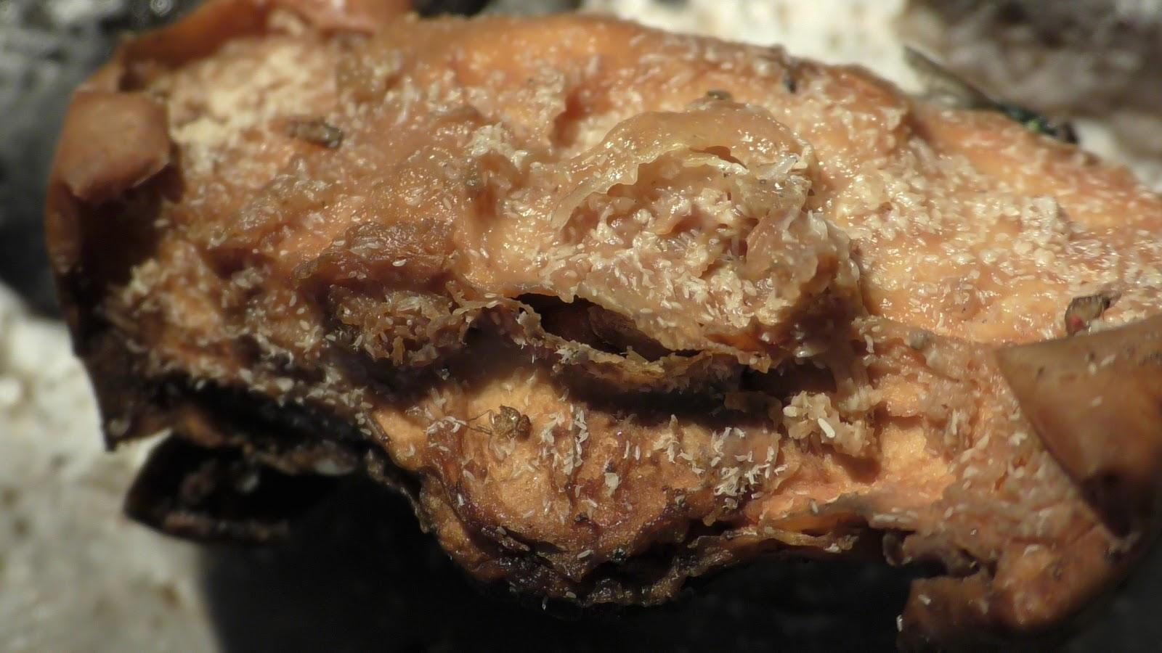
Figure 2: A close up photo of the decaying apple with egg cases and larvae of all stages and some pupa. Mostly Drosophila stages are present but with a few of the blow fly.

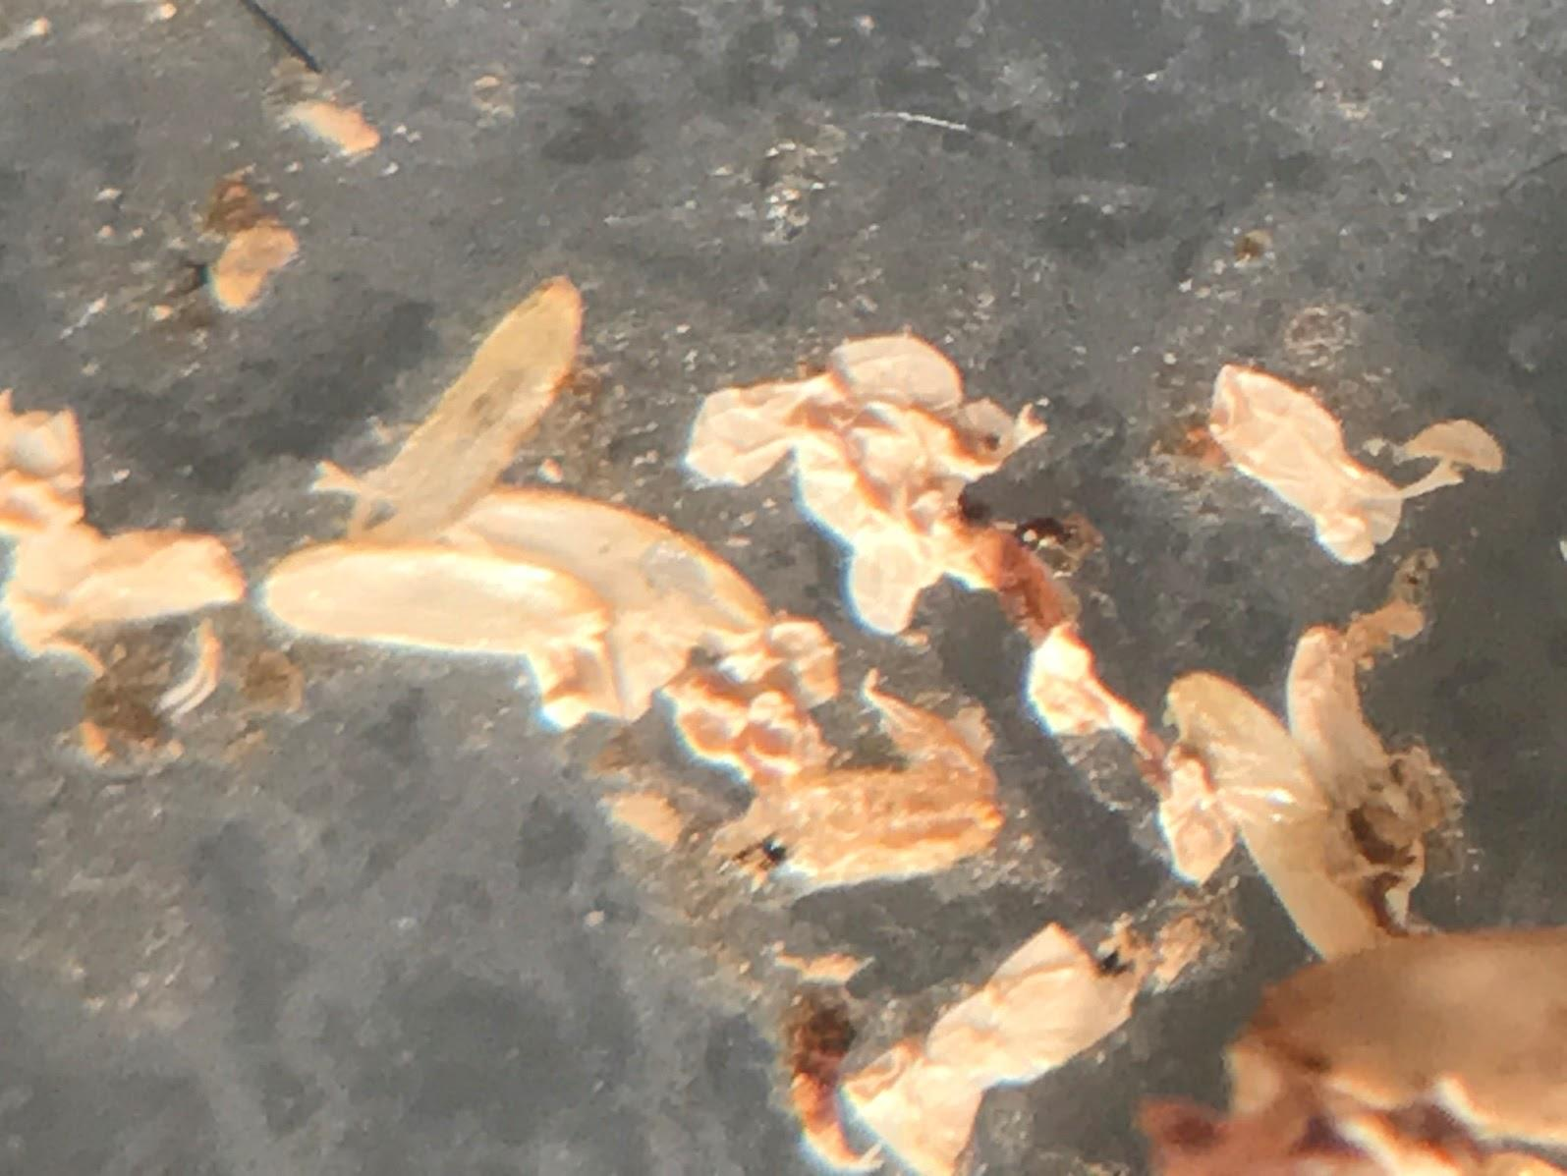
Figure 3: Several empty pupa cases of Drosophila were found on the ground rather than the apple.

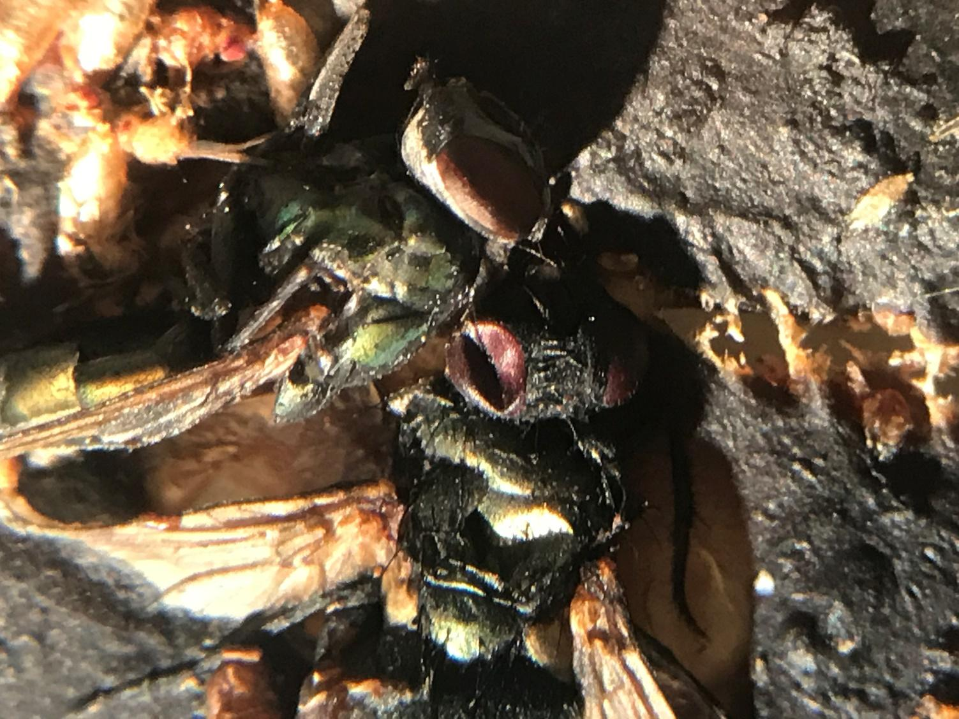
Figure 4: Simulated photo of the tongue of body (in practice this is of beef liver).
Dead blow flies and empty pupa cases of blow flies are noted.

Figure 5: These pupae are found in the grass between the apple and the subject’s face. The larger one is of the blow fly.

The activity is divided into flexible tasks for teachers to adjust as needed but to provide a logical framework for stepwise learning.
Task 1: Look over the data provided and come up with a list of information about the insects that could help to estimate the time in which the animal/person might have died. Students make lists and then write them out on a board and see how many of the same items were chosen.
Task 2: Examine the literature and web sources to find the life cycle of fruit flies and blow flies and how this relates to forensics. Topics to pay attention to: Temperature, food source, crowding, how to tell the life stages apart, length of life stages and how conditions may affect them.
Task 3: Compile the data provided to estimate at minimum how long the body and fruit must have been present. Put a timeline together based on the developmental stages of the insects. Back date down to egg laying and list air temperatures with the dates (day/night).
Optional- Task 4: Set up a simulation with a cut apple and beef liver. Add fruit flies and blow flies. Conduct experiments at room temperature and monitor developmental stages.
Optional- Task 5: Set up isolated fruit flies and blow files in separate containers with food. Use incubators to simulate temperature changes and monitor developmental stages.

Please see website for more details
http://web.as.uky.edu/Biology/faculty/cooper/ABLE-2021/ABLE-2021-Body%20farm/Home-Forensics%20for%20the%20body%20farm-ABLE%202021.htm

Details for each task.
Task 1: Potential variables students may consider: Body temperature, condition of corpse (skin broken or intact), insect larvae inside body or only around mouth and eyes, leaking body fluids, dehydration, hair falling out, grass/plants underneath dead or look fresh and green, insects under body, wild animal bites from dogs or other large animals, insects associated with body. If insects present, what stages?
Apple: dried out or moist, bacteria, fungi, insects present. If insects present, what stages?
Environment: Temperature of the last few days, precipitation, wind.

Task 2: Google searches on:
Life cycle Drosophila
Life cycle blow flies (Phaenicia sericata)
How to stage larvae, temperature effects on insect development
How to determine how long an animal is dead, forensics dead animal, forensics insects.

Task 3: List out the stages of the two different types of larvae, eggs, pupa, and if pupa cases are enclosed. Try to make a developmental curve based on temperatures. Back calculate the potential dates that the person and apple were exposed to the open environment. Use Netlogo simulation to examine how fast a population can grow depending on number of adults and sex of adults.
See the information on these hot links
One needs to download the free netlogo software for these modules to function
https://ccl.northwestern.edu/netlogo/download.shtml
Module 1 .... Module 2 .... Module 3

Task 4: Go over how to simulate the scene with mixed fly species and how to monitor the food sources and insect development. For an outside simulation, one needs a cage to keep other animals from running off with content. If the cage is small enough then it can be brought indoors. If one wanted to simulate outdoor conditions, one could use a semi closed or could use chicken wire to make it open for flies but to keep large animals away. This would be a more natural condition.
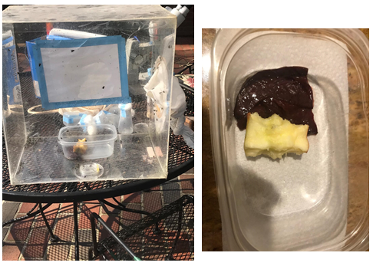
Figure 6: A plastic cage with screening to allow air in and out. Apple and beef liver placed inside along with adult Drosophila and blow flies
Task 5: Go over how to investigate individual fly species and effects of the environment on the developmental cycle. One can make agar plates with LPS within the agar or food and at different concentrations. D. melanogaster avoid eating food containing bacterial LPS. This gustatory avoidance was shown to be mediated through a TRPA1 receptor (Soldano, Alpizar Boonen et al…2016).
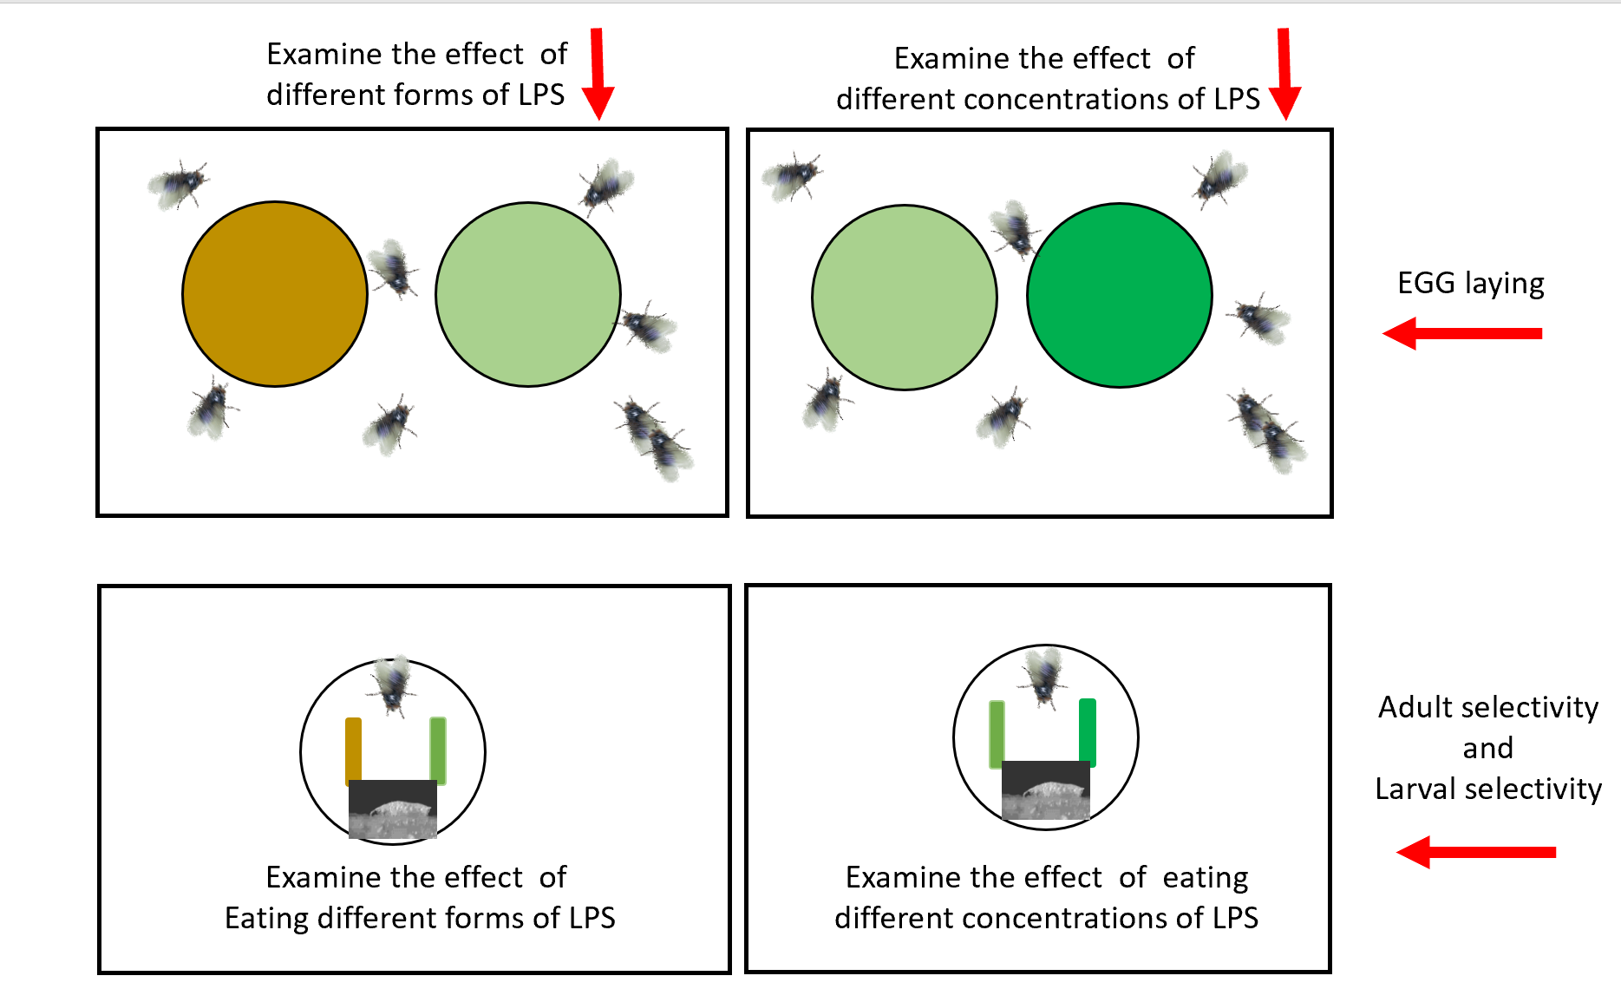
Figure 7: A potential experimental design to investigate the choices of blow flies and Drosophila for egg laying depending on the presence and concentration of LPS in the agar (top panel). The choice of eating food not tainted or tainted with LPS and variation in concentration of LPS. Here food is placed close together in strips so larvae could choose relatively easily between the food groups after emerging from the egg cases.
Discussion

Now that one has a snapshot of the conditions in which the body and apple were found, one should be able to determine how long (approximate days or hours) the body and the apple have been in the environment.
Depending on the tasks assigned to you, write out a description of your notes from each task as if presenting a report to a group of fellow forensic scientists. Provide details on how the outcome of how each task was managed. In explaining your results, explain the steps that led you to this outcome, as well as any potential confounding factors.

Cited References

Soldano A, Alpizar YA, Boonen B, Franco L, López-Requena A, Liu G, Mora N, Yaksi E, Voets T, Vennekens R, Hassan BA, Talavera K. 2016. Gustatory-mediated avoidance of bacterial lipopolysaccharides via TRPA1 activation in Drosophila. Elife. 5:e13133.

Materials

- One bottle of larvae that has been stored at room temperature.
- Apple & beef liver if recreating the module.
- Wire cage for outdoor/indoor recreation of conditions (use nylon stocking for netting screen or chicken wire)
- 2 medium-size Petri dishes (for feeding experiments)
- Small paint brush
- Corn meal food for mixing with LPS
- LPS from Sigma-Aldrich chemical Co.
- Dissecting microscope or phone camera
- For remote learning (kit or download files)

Notes for the Instructor

The challenging aspect of conducting a live animal project is being able to monitor the set up if placed outside, due to interference from wild animals. If held indoors, the potential for flies to escape the plastic chamber is a possibility. This project is best conducted in the season where blow flies are easily recruited with bait left outside. In addition, fruit flies are readily be obtained on warm days in many locations; however, they can also be obtained by contacting most university researchers who work with fruit flies, or by ordering them from a stock center. So if you want outsides flies to go to the food sources then use chicken wire around a food items to keep raccoons, squirrels and birds out. If one wanted to maintain flies one put in the cage but need air to flow, then use material from nylon stockings to cover the holes.
It may be advantageous to have the students write a report of their findings and how their conclusions were reached.

Students should find that the body and fruit have been present at the scene of death for [x] days, based on the temperature, weather, and life stages of the fruit flies and blow flies. Students should explain the steps that led them to this outcome, as well as any potential confounding factors. Their task is not to draw conclusions about the cause of death, only to use various sources of information to deduce a reasonable time frame. Encourage discussion about different factors that may cause the body and fruit to decompose and promote insect development at different rates.

If an instructor wanted to use their local environments or place a date and location for the scene, then students could look up weather information online or examine ways to best estimate the weather conditions during the time frame.

Examining how flies choose between food that is tainted with LPS can stimulate discussion about what types of bacteria are in the environment and how these species differ. Different bacterial strains of LPS can be obtained from Sigma-Aldrich chemical company. There are likely some forms of LPS which will generate unique results and could be used for reporting novel findings as there is not an exhaustive amount of published research on this topic. Publications in undergraduate or primary research journals are a possibility.

The use of LPS instead of bacteria offers an easier environment to control than having to grow bacteria and worry about identification of species. It would be best if the instructor of the course was the one to mix the food and LPS as well as make agar dishes with LPS as the LPS needs to be weighed out in a hood with proper protective gear so as not to ingest or inhale the powder.

There are many variations to this module which can be altered each time it is taught. The environmental conditions can be changed as well as the type of insects used. Pill bugs and other common insects can be used to examine food preference and effects of LPS forms.

For remote learning with participants please download a kit for sending to students after adjusting the content as needed. http://web.as.uky.edu/Biology/faculty/cooper/ABLE-2021/ABLE-2021-Body%20farm/Home-Forensics%20for%20the%20body%20farm-ABLE%202021.htm

Cited References

National Research Council. 2012. A Framework for K-12 Science Education: Practices, Crosscutting Concepts, and Core Ideas. (2012). Committee on a Conceptual Framework for New K-12 Science Education Standards. Board on Science Education, Division of Behavioral and Social Sciences and Education. Washington, DC: The National Academies Press.
Acknowledgments
Funded by Department of Biology, University of Kentucky for laboratory supplies and personal funds of Robin Cooper for attending ABLE and presenting the module.
About the Authors
Oscar Istas is an undergraduate student at the University of Kentucky. He will be receiving a B.S. in Biology while minoring in Entomology.
Abigail Greenhalgh is an undergraduate in Biology at the University of Kentucky. She plans on pursuing a graduate degree in animal physiology.

Erin Richard is a lecturer at the University of Kentucky where she teaches microbiology lecture and laboratory. She received a BS in Chemical Engineering from the University of Kentucky in 2004 and a PhD in Molecular Biology from the Medical University of South Carolina in 2009. She was an instructor at the College of Charleston before returning to the University of Kentucky in 2014.

Jate Bernard is a medical student at the University of Kentucky. He received a B.S. in Chemistry from the University of Virginia.

Rebecca Krall earned an undergraduate degree in elementary education from Virginia Tech in 1988, certified in science and literacy in grades K-8. After teaching science in grades six through eight, she earned a masters and doctorate in science education from the University of Virginia. She currently teaches science methods and effective uses of technology at the University of Kentucky. Her current research interests include developing K-8 teachers’ scientific knowledge and pedagogy for creating authentic science experiences for students, the effect on student learning, and teachers’ abilities to notice, interpret, and apply student thinking during their instruction.

Tawny Aguayo-Williams is a secondary biology teacher at West Jessamine High School in Nicholasville, Kentucky. She received a B.S. in Biology from Alice Lloyd College in 2014 and a M.A. in Secondary STEM Education from University of Kentucky in 2020.

Robin Cooper is an instructor of animal physiology and neurophysiology at the University of Kentucky. He received a double major in chemistry and zoology from Texas Tech in 1983 and a PhD in Physiology from Texas Tech Medical School in 1989. He has been at the University of Kentucky since 1996.

Mission, Review Process & Disclaimer

The Association for Biology Laboratory Education (ABLE) was founded in 1979 to promote information exchange among university and college educators actively concerned with teaching biology in a laboratory setting. The focus of ABLE is to improve the undergraduate biology laboratory experience by promoting the development and dissemination of interesting, innovative, and reliable laboratory exercises. For more information about ABLE, please visit http://www.ableweb.org/.
Papers published in Advances in Biology Laboratory Education: Peer-Reviewed Publication of the Conference of the Association for Biology Laboratory Education are evaluated and selected by a committee prior to presentation at the conference, peer-reviewed by participants at the conference, and edited by members of the ABLE Editorial Board.

Citing This Article
Oscar Istas, Abigail Greenhalgh, Erin E. Richard, Jate Bernard, Rebecca Krall, Tawny Aguayo, and Robin L. Cooper. 2020. Forensics for the body farm: Preferences for the medicinal blow fly (Phaenicia sericata) and fruit fly (Drosophila melanogaster). Article # In: McMahon K, editor. Advances in biology laboratory education. Volume 41. Publication of the 41st Conference of the Association for Biology Laboratory Education (ABLE). http://www.ableweb.org/volumes/vol-41/?art=#

Compilation © 2020 by the Association for Biology Laboratory Education, ISBN 1-890444-17-0. All rights reserved. No
part of this publication may be reproduced, stored in a retrieval system, or transmitted, in any form or by any means, electronic, mechanical, photocopying, recording, or otherwise, without the prior written permission of the copyright owner.
ABLE strongly encourages individuals to use the exercises in this volume in their teaching program. If this exercise is used solely at one’s own institution with no intent for profit, it is excluded from the preceding copyright restriction, unless otherwise noted on the copyright notice of the individual chapter in this volume. Proper credit to this publication must be included in your laboratory outline for each use; a sample citation is given above.

